Student Name: Mallareddy Sai Prakash
Student Id: 11814552
Roll no: 53
Email: saiprakash1102@gmail.com
Github link: https://github.com/saiprakash1102/OS-CODE
Question num: 7
Code:
#include<stdio.h>
#include<string.h>
#include<conio.h>
void main()
{
char p[10][5],temp[5];
int i,j,pt[10],wt[10],totwt=0,pr[10],temp1,n;
float avgwt;
printf("enter no of processes:");
scanf("%d",&n);
for(i=0;i<n;i++)
{
printf("enter process %d name:",i+1);
scanf("%s",&p[i]);
printf("enter process time:");
scanf("%d",&pt[i]);
printf("enter priority:");
scanf("%d",&pr[i]);
}
for(i=0;i<n-1;i++)
{
for(j=i+1;j<n;j++)
{
if(pr[i]>pr[j])
{
temp1=pr[i];
pr[i]=pr[j];
pr[j]=temp1;
temp1=pt[i];
pt[i]=pt[j];
pt[j]=temp1;
strcpy (temp,p[i]);
strcpy (p[i],p[j]);
strcpy (p[j],temp);
}
}
}
wt[0]=0;
for(i=1;i<n;i++)
{
wt[i]=wt[i-1]+wt[i-1];
totwt=totwt+wt[i];
}
avgwt=(float)totwt/n;
printf("p_name:\t p_time:\t priority:\t w_time:\n");
for(i=0;i<n;i++)
{
printf(" %s\t %d\t %d\t %d\n" ,p[i],pt[i],pr[i],wt[i]);
}
printf("total waiting time=%d\n avg waiting time=%f",totwt,avgwt);
int ts,pid[10],need[10],wt1[10],tat[10],i1,j1,n2,n1;
int bt[10],flag[10],ttat=0,twt=0;
float awt,atat;
printf("\nEnter the number of Processors \n");
scanf("%d",&n);
n1=n;
printf("\n Enter the Timeslice \n");
scanf("%d",&ts);
for(i=1;i<=n;i++)
{
printf("\n Enter the process ID %d",i);
scanf("%d",&pid[i]);
printf("\n Enter the Burst Time for the process");
scanf("%d",&bt[i]);
need[i]=bt[i];
}
for(i=1;i<=n;i++)
{
flag[i]=1;
wt[i]=0;
}
while(n!=0)
{
for(i=1;i<=n;i++)
{
if(need[i]>=ts)
{
for(j=1;j<=n;j++)
{
if((i!=j)&&(flag[i]==1)&&(need[j]!=0))
wt[j]+=ts;
}
need[i]-=ts;
if(need[i]==0)
{
flag[i]=0;
n--;
}
}
else
{
for(j=1;j<=n;j++)
{
if((i!=j)&&(flag[i]==1)&&(need[j]!=0))
wt[j]+=need[i];
}
need[i]=0;
n--;
flag[i]=0;
}
}
}
for(i=1;i<=n1;i++)
{
tat[i]=wt[i]+bt[i];
twt=twt+wt[i];
ttat=ttat+tat[i];
}
awt=(float)twt/n1;
atat=(float)ttat/n1;
printf("\n\n Process: \t Process ID: \t BurstTime: \t Waiting Time: \t TurnaroundTime: \n ");
for(i=1;i<=n1;i++)
{
printf("\n %5d \t %5d \t\t %5d \t\t %5d \t\t %5d \n", i,pid[i],bt[i],wt[i],tat[i]);
}
printf("\n The average Waiting Time=4.5f",awt);
printf("\n The average Turn around Time=4.5f",atat);
}

Description:
In this question, I have implemented the scheduling to implement a queue with two levels. I have considered the 1st level as Fixed Priority Preemptive Scheduling and 2nd level as Round Robin Scheduling. For a Fixed Priority scheduling, i have considered the “0” as highest priority and priority preference continues so on...And i implemented the conditions like...if one process is scheduled and running and another process came with the highest priority then the process with highest priority pre-empts the process with least priority and that moves to the Second level queue . And also the time, which process executing is also considered as the multiples of two. The process in the Second level queue will complete their execution, According to the Property of Round Robin Scheduling which is always preemptive scheduling. And also I considered that the Queue 2 process will processed after the Queue 1 becomes empty. Because as we considered that the Queue 2 has least Priority than the Queue 1.As I have mentioned above code that the implemented the Fixed Priority Preemptive Scheduling and Round Robin Scheduling as 1st level and 2nd level respectively...which suggests us about the MULTI LEVEL QUEUE. By executing the above code we get the output to enter the user details like “Enter the number of Process:”,”Name of the Process”, ”Enter the process time”, ”Enter Priority”....for the Processes and it will display the Average Waiting time. That is the code I have implemented.
Description of Algorithm:
“MULTI LEVEL QUEUE” Algorithm is used in this code. This algorithm is applied when more than one queue is there. In this algorithm, the Queue with highest priority will be processed first and then the remaining algorithm will be processed according to their priority. Likewise, in the above program, Fixed Priority Preemptive Scheduling is processed first and after that Round Robin Scheduling will be processed.
Complexity of Algorithm:
The complexity of the above code is n*n*n. Since I have used 3 if-else loops (i.e. 3 times the code is getting executed in different conditions). Therefore, the Complexity of the above code is n^3.
Constraints:
The time for which the process executes is considered as multiples of “2”:
If(i=0; i%2 ==0; i++)
The Process name must not be same:
For(i=0;i<=n;i++)
The Process time or Priority must not be negative:
If(i=0;i<n;i++) //for both process time and priority
Methods used:
Fixed Priority Preemptive Scheduling is used in the first level queue.
Round Robin Scheduling is used in the second level queue.
In the above code, from line 24 we implemented these methods to the code.
Boundary Conditions:
The number of Processes should not be more than the Process number we entered.
The process time must be the multiples of two.
Priority and Process time must be greater than the zero.
Priority of Queue 2 must be less than the Queue1.
Queue 2 must process only after the completion of execution of Queue 1.
Test Cases:
In this code, we can assign the values by the user. So, the output was depends on the user inputs. The sample output which I got is:
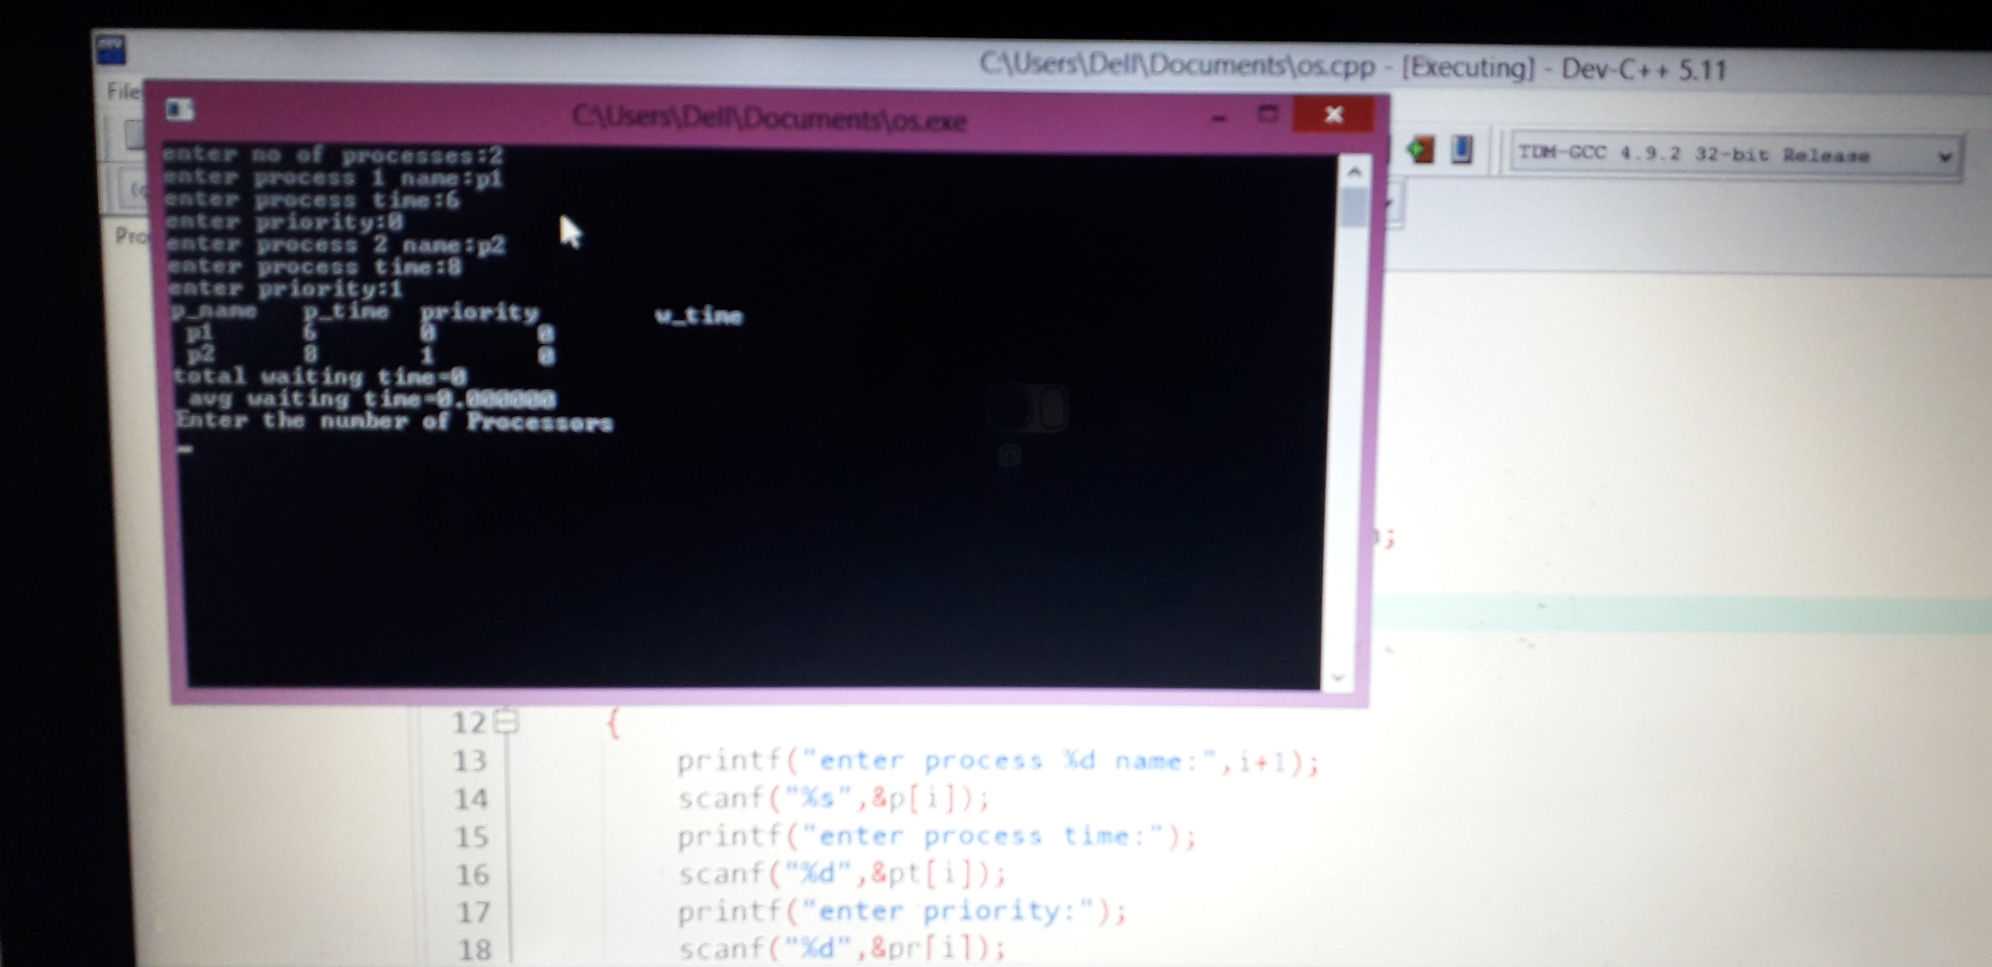
Above shown picture is an sample output, the inputs are taken by user randomly.

Github Link:
https://github.com/saiprakash1102/OS-CODE

